With training data size1000:

29:

Decision Tree:

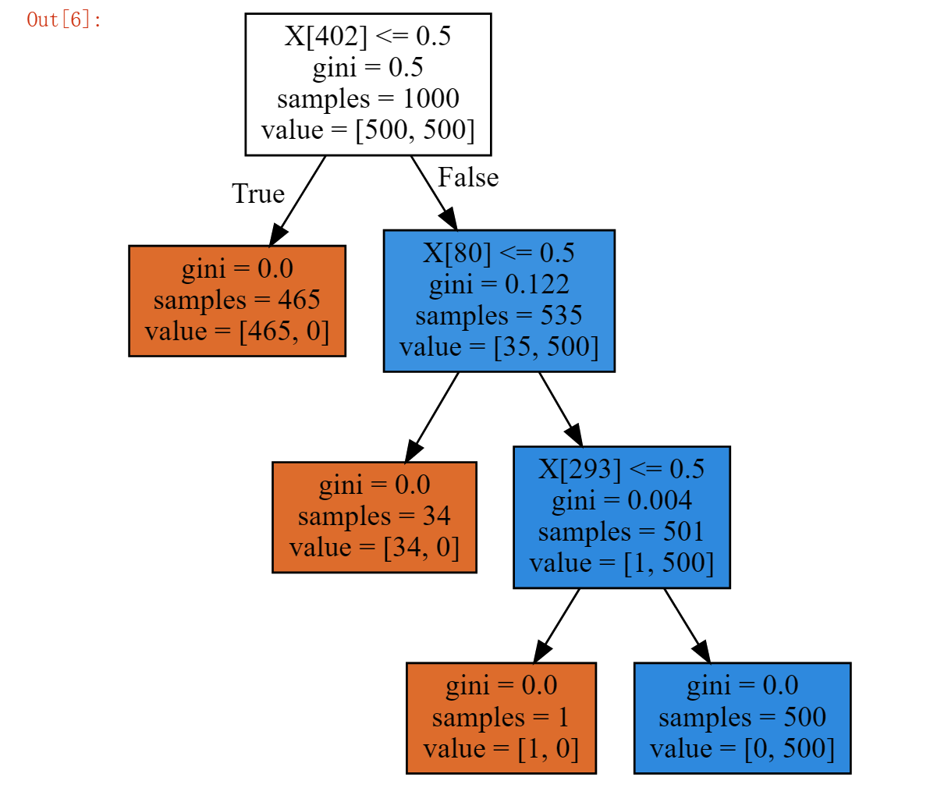

Fix&remove rule:



Result:

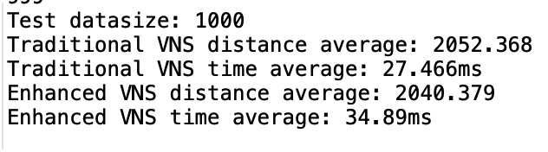

52:

Decision Tree:

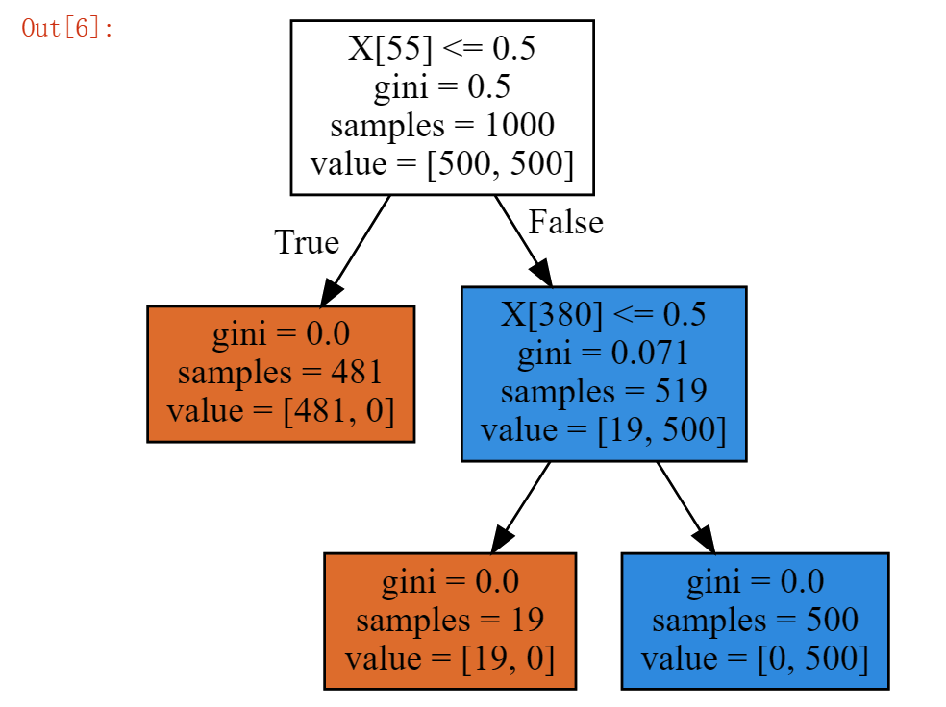

Fix&remove rule:

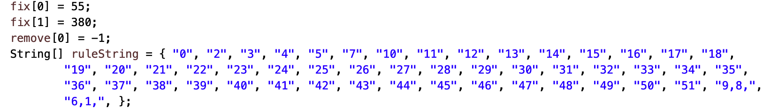

Result:

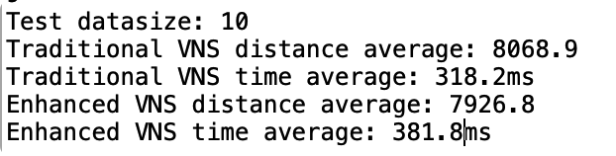

76:

Decision Tree:

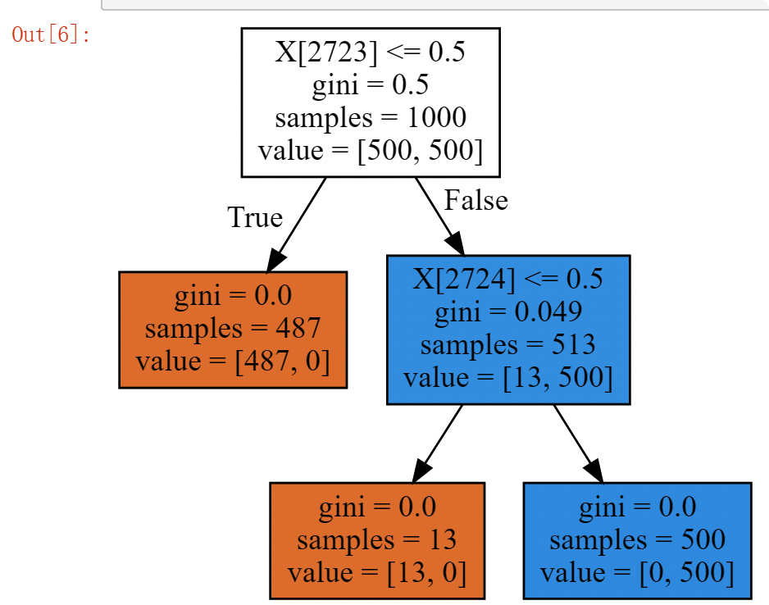

Fix&remove rule:

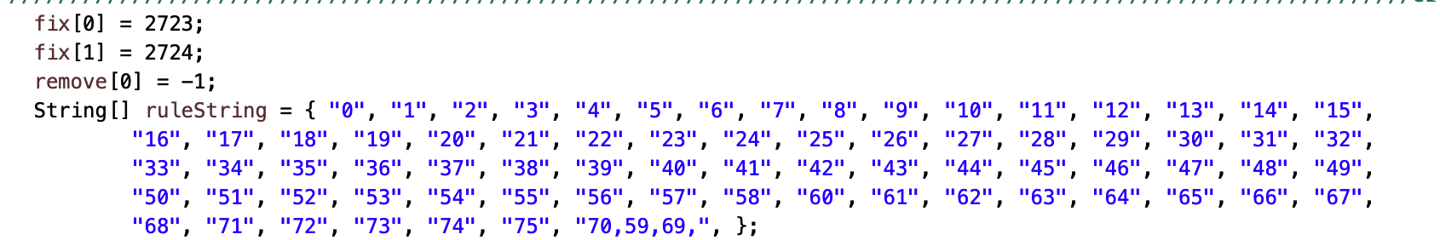

Result:

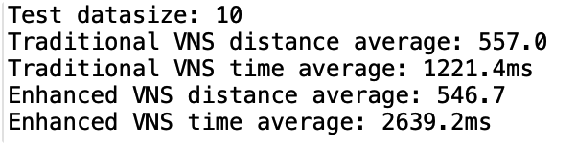

size101:

Decision Tree:

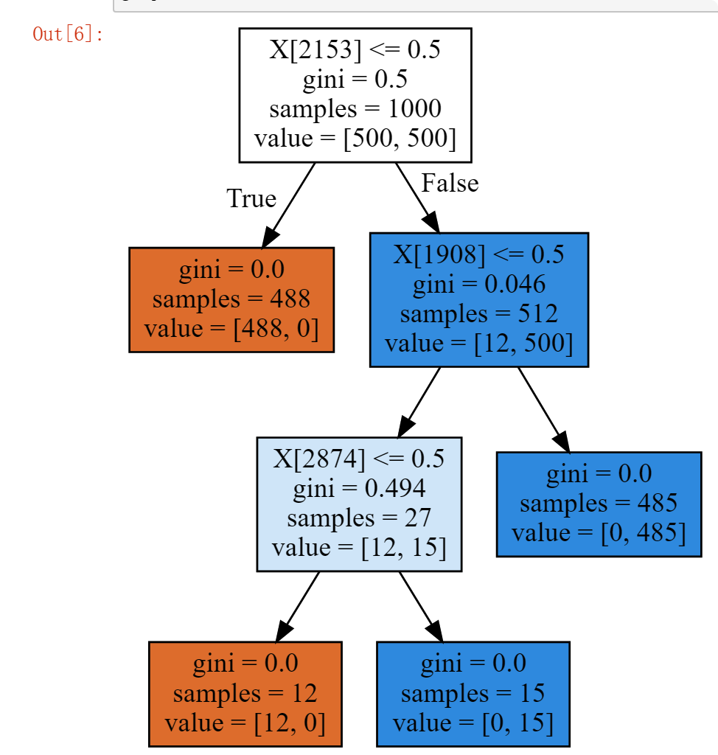

Fix&remove rule:

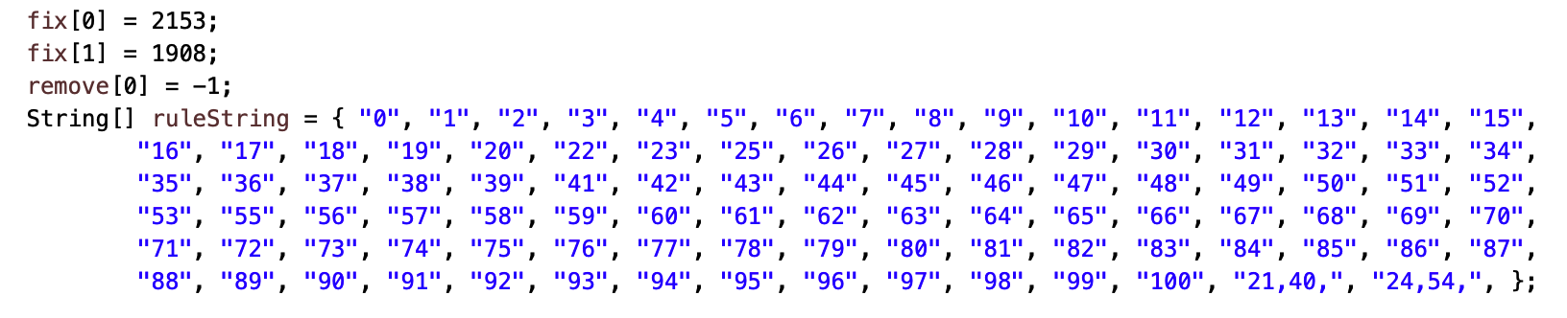

Result:

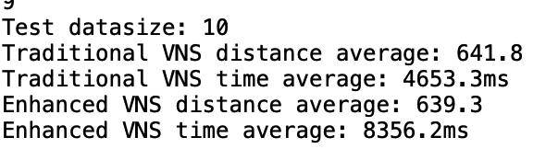

DataByGenerator:

Only change Range:

Range10, average controller 40, instance size 29 , datasize 1000

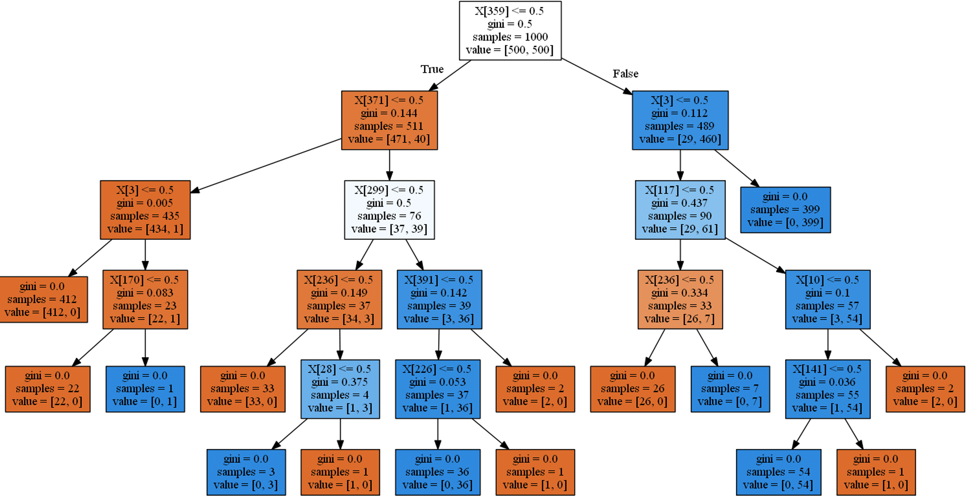

Range 100 , average controller 40, instance size 29 , datasize 1000

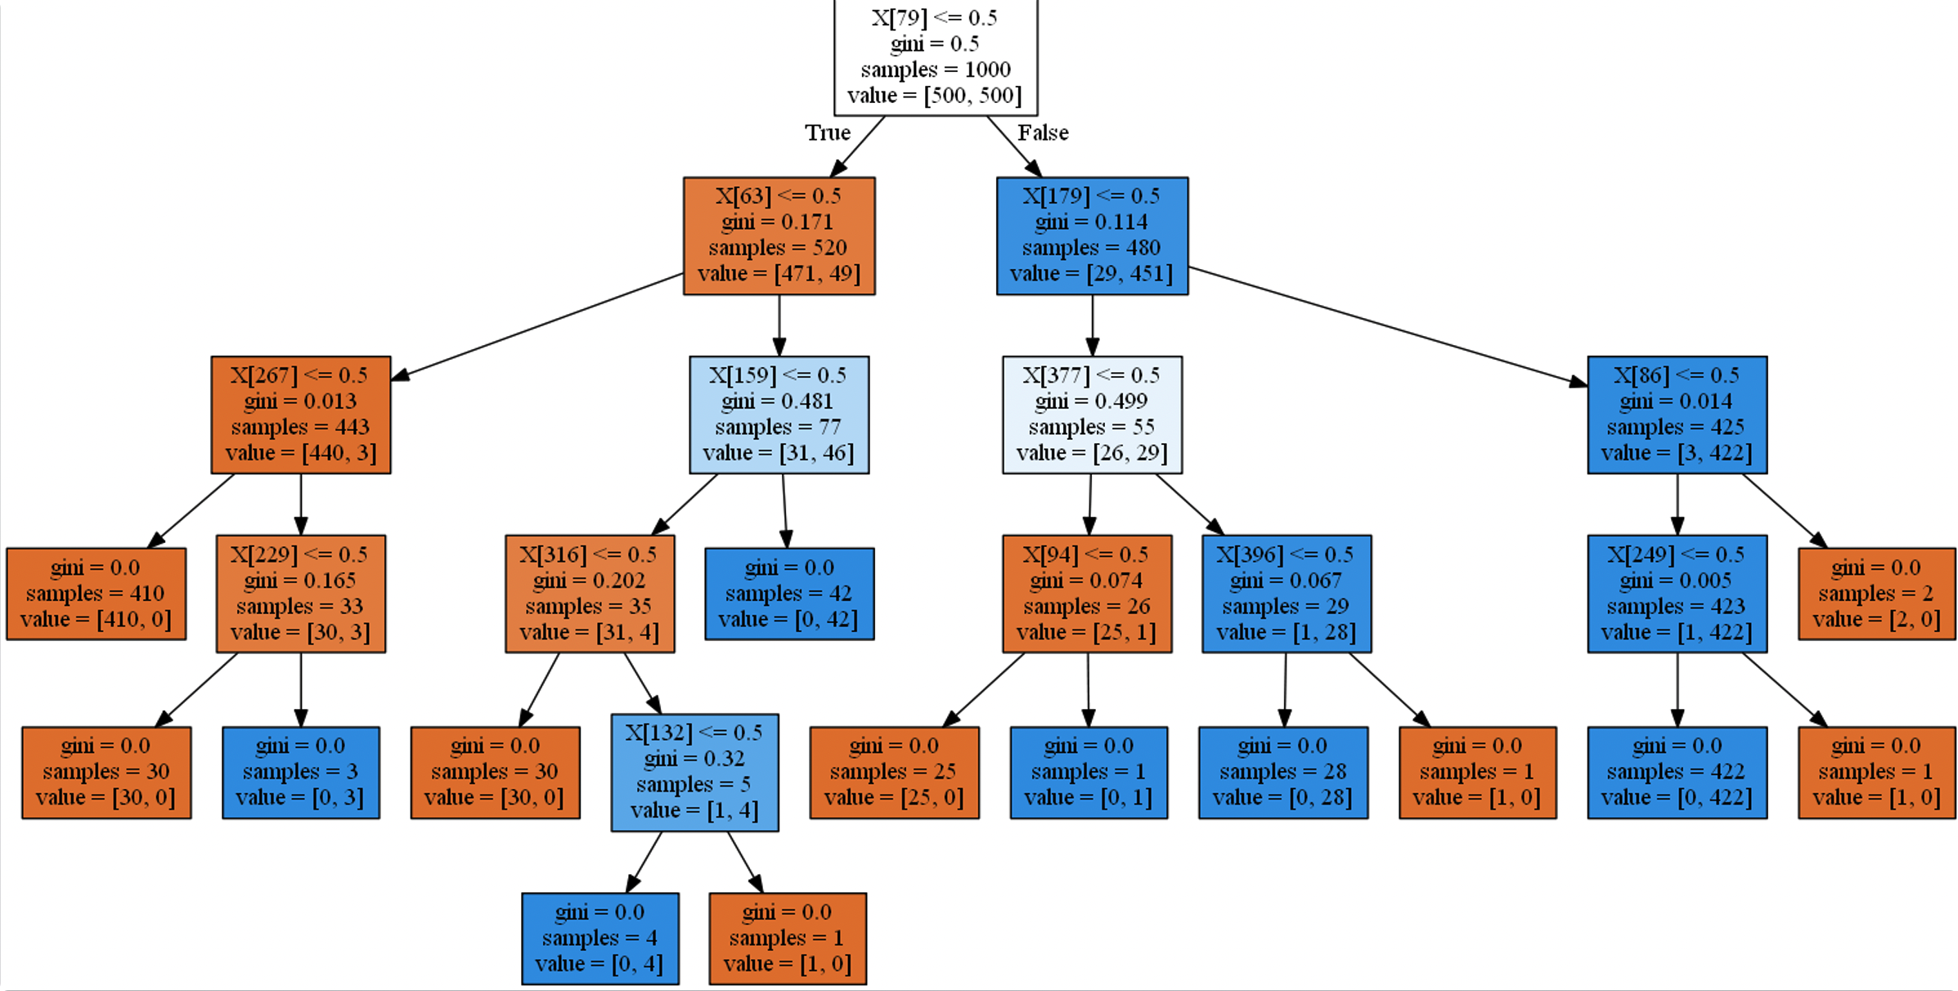

Range 1000, average controller 40, instance size 29 , datasize 1000

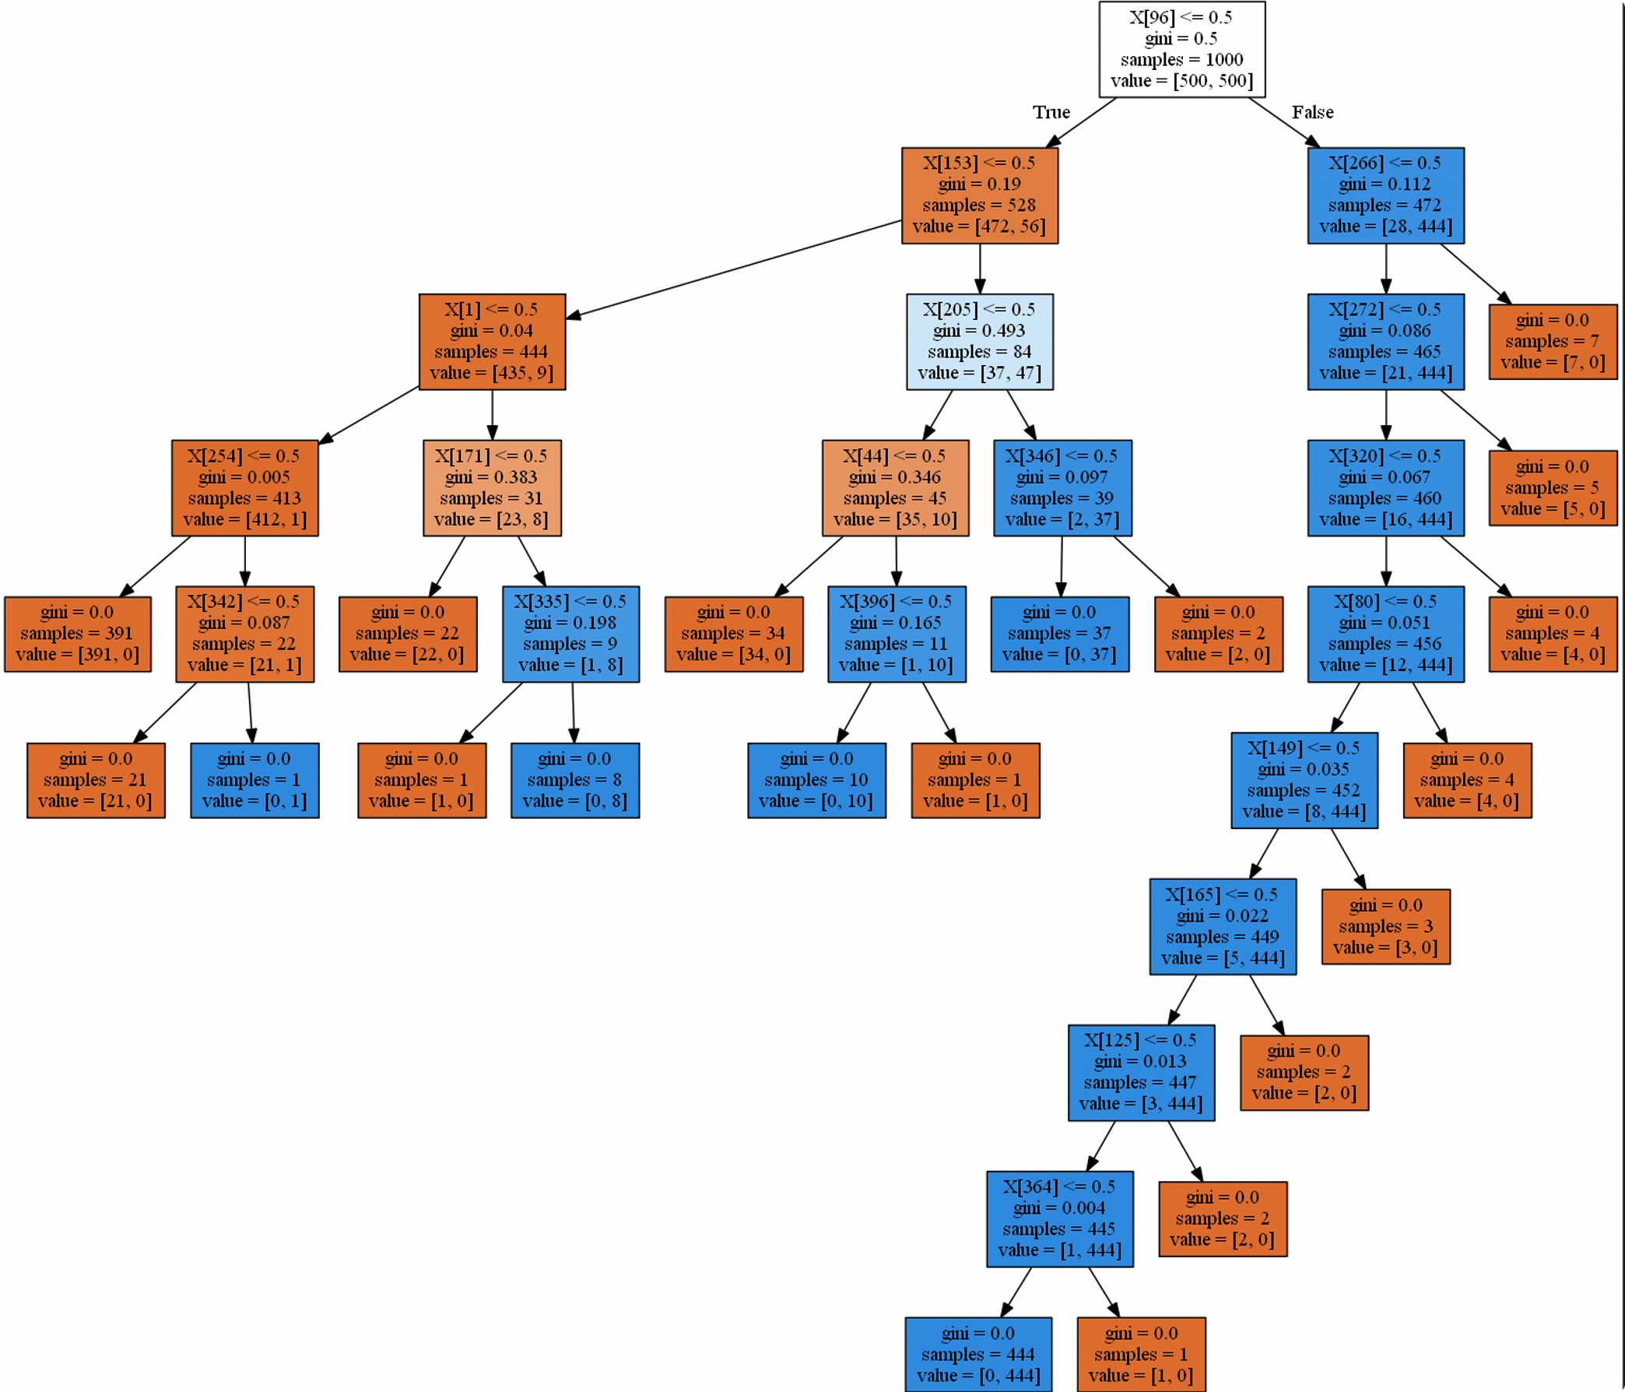

Only change average controller:

Range 1000, average controller 400, instance size 29 , datasize 1000

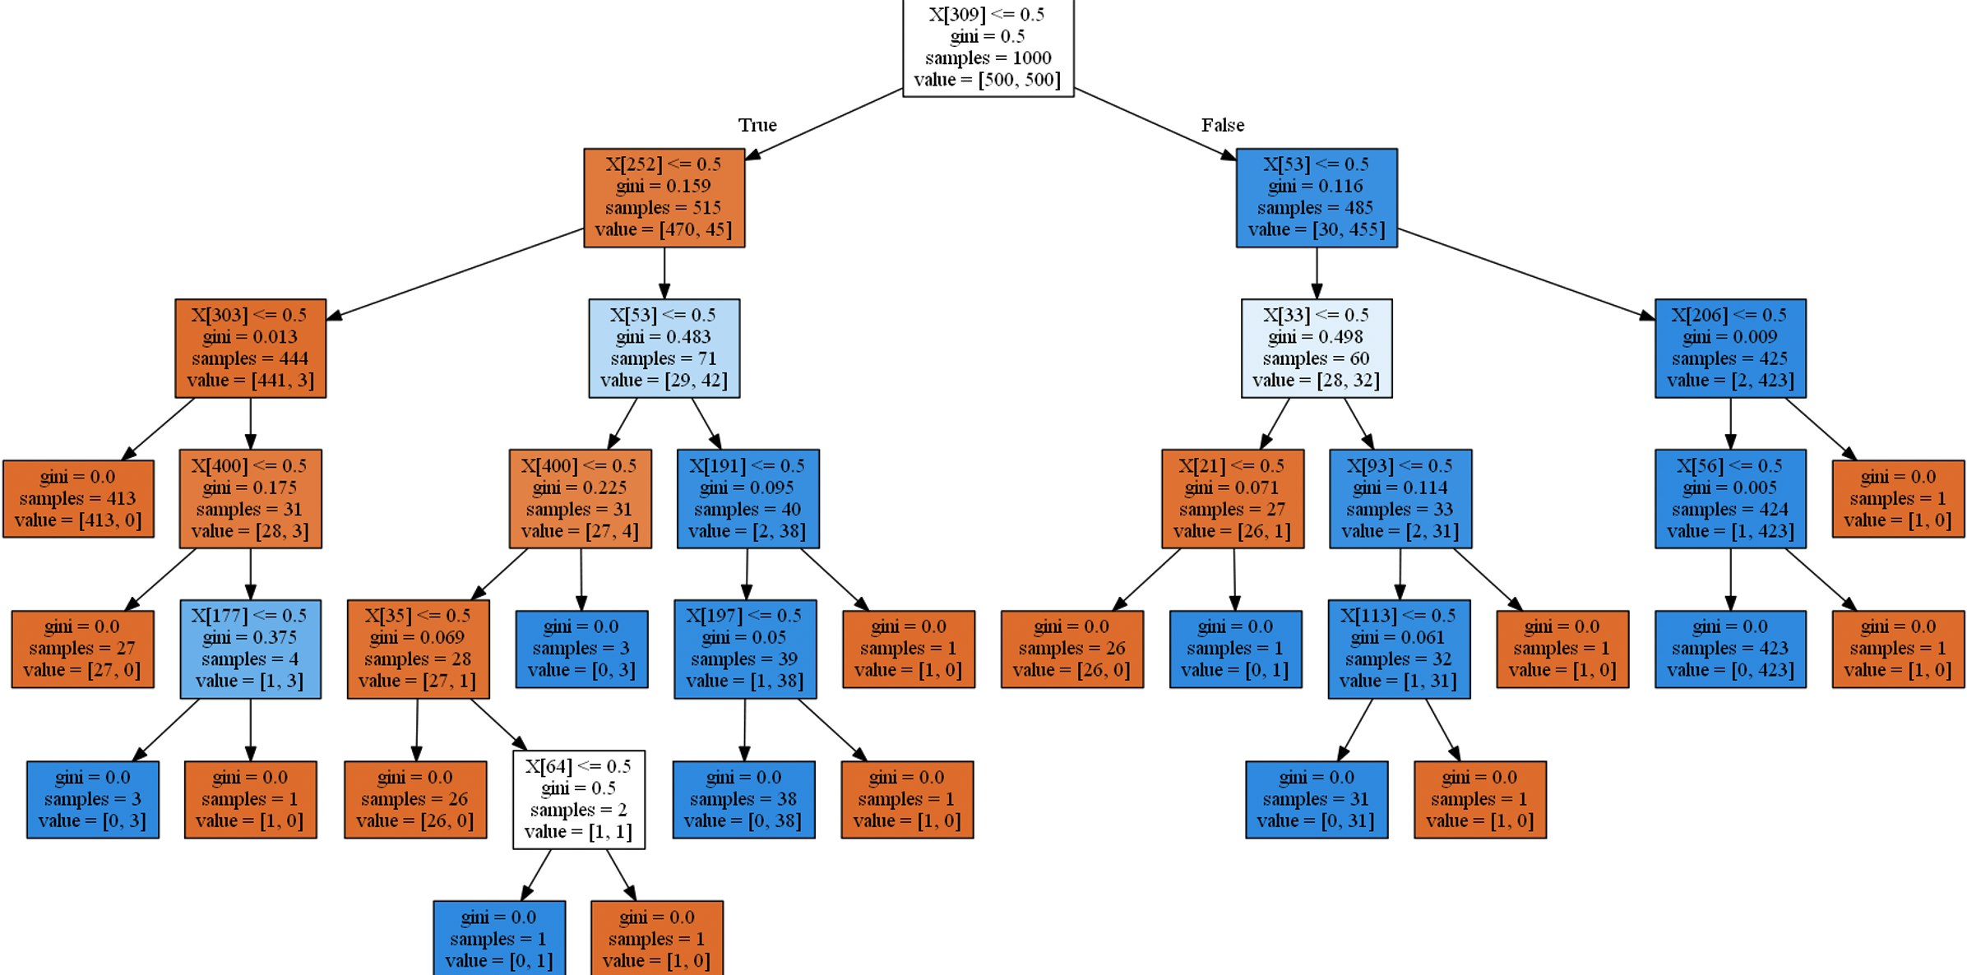

Range 1000, average controller 4000, instance size 29 , datasize 1000

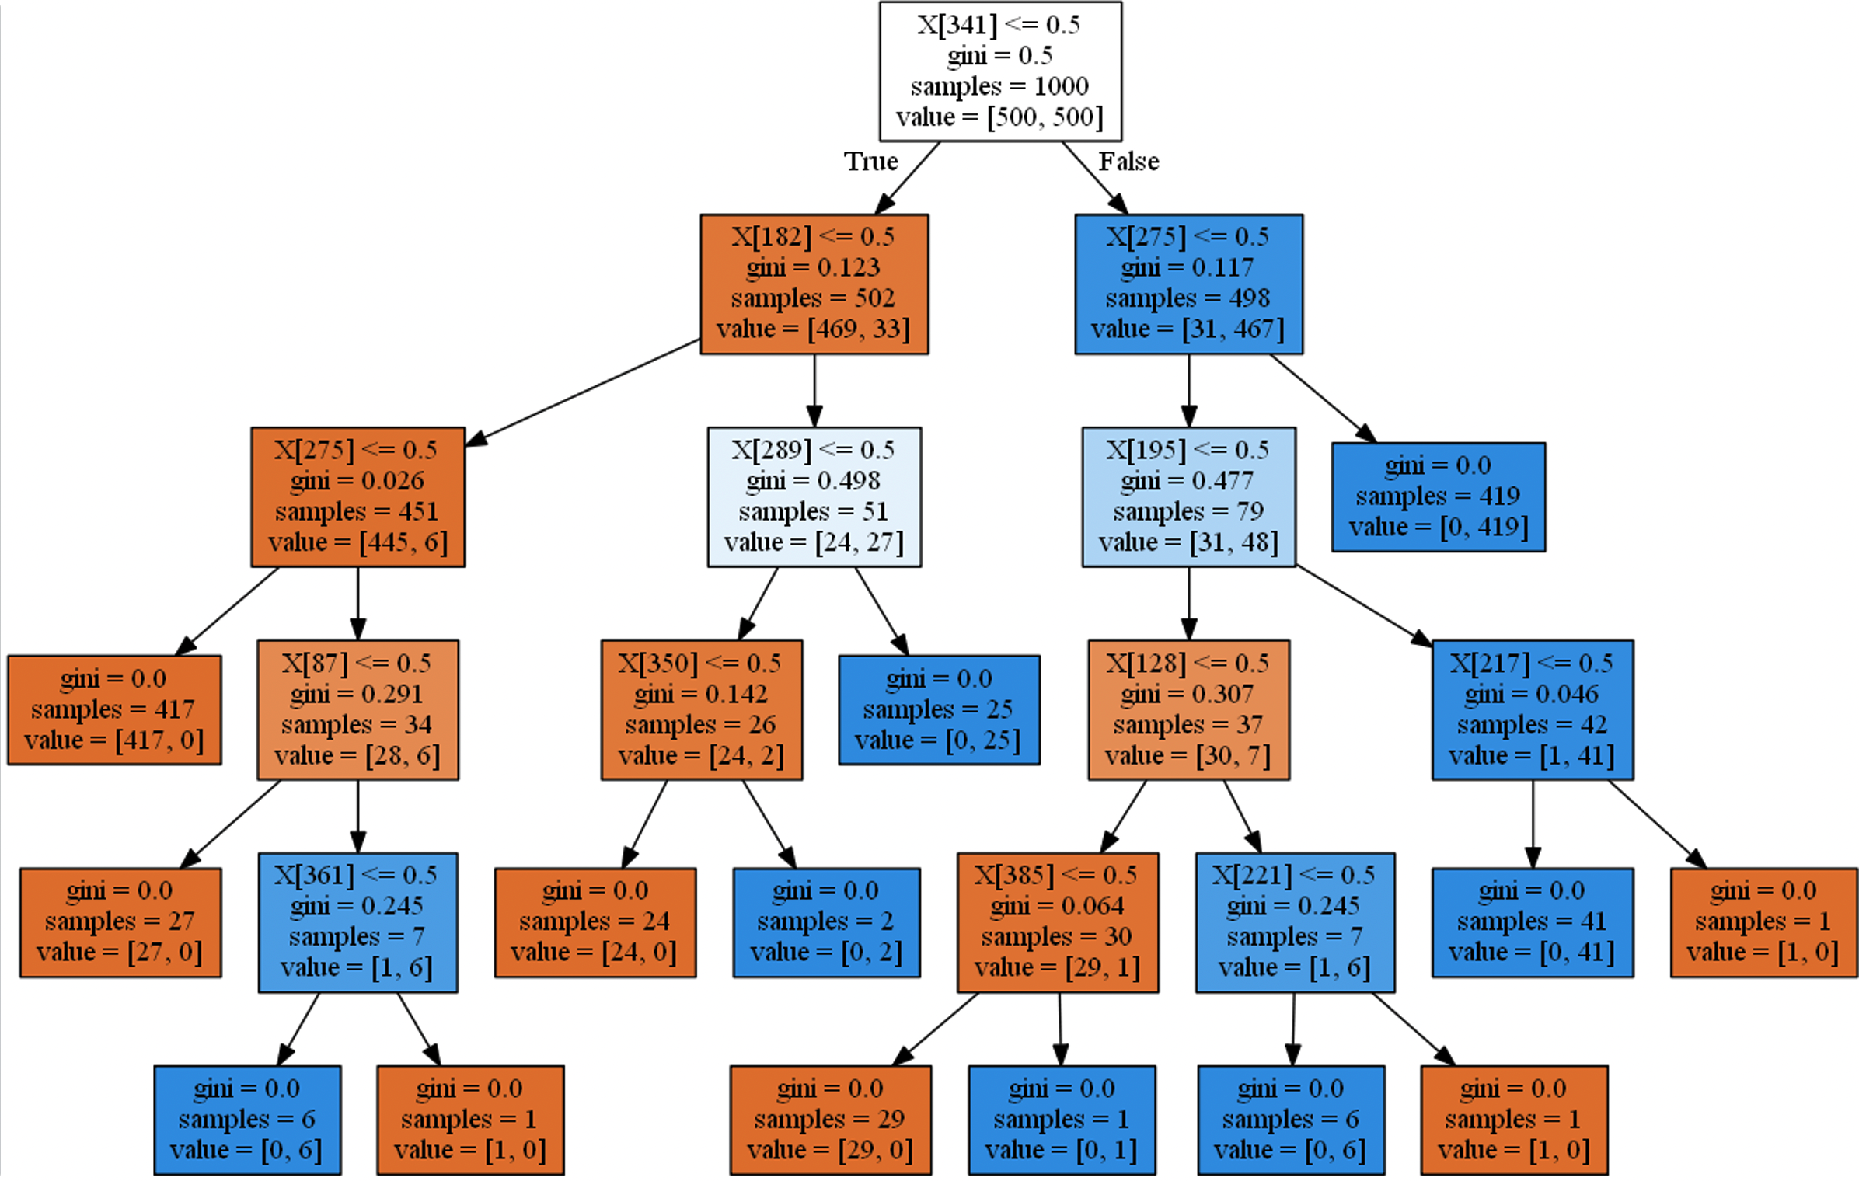

Only change instance size:

Range 1000, average controller 40, instance size 100, datasize 1000

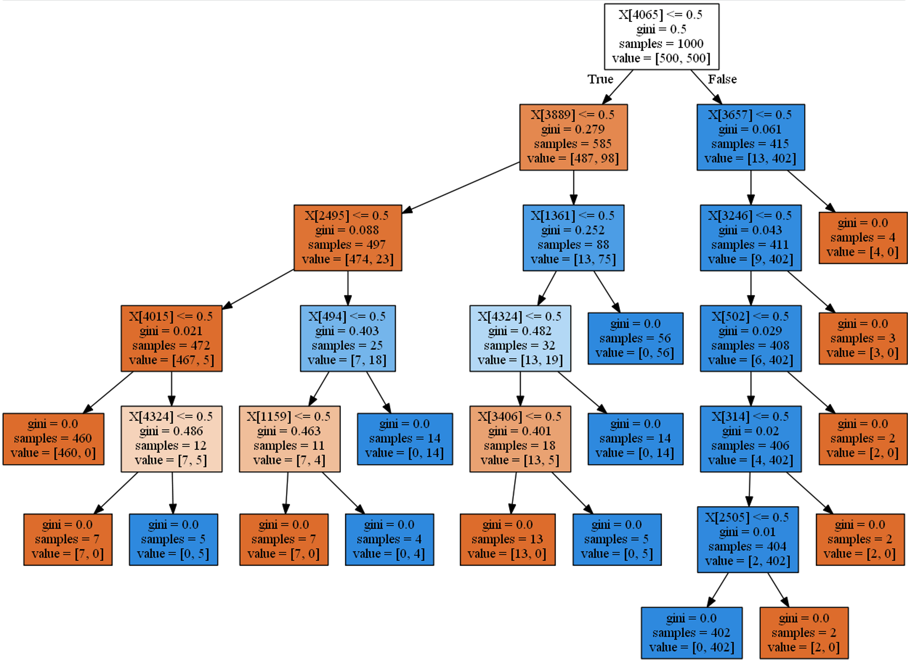

Range 1000, average controller 40, instance size 15, datasize 1000

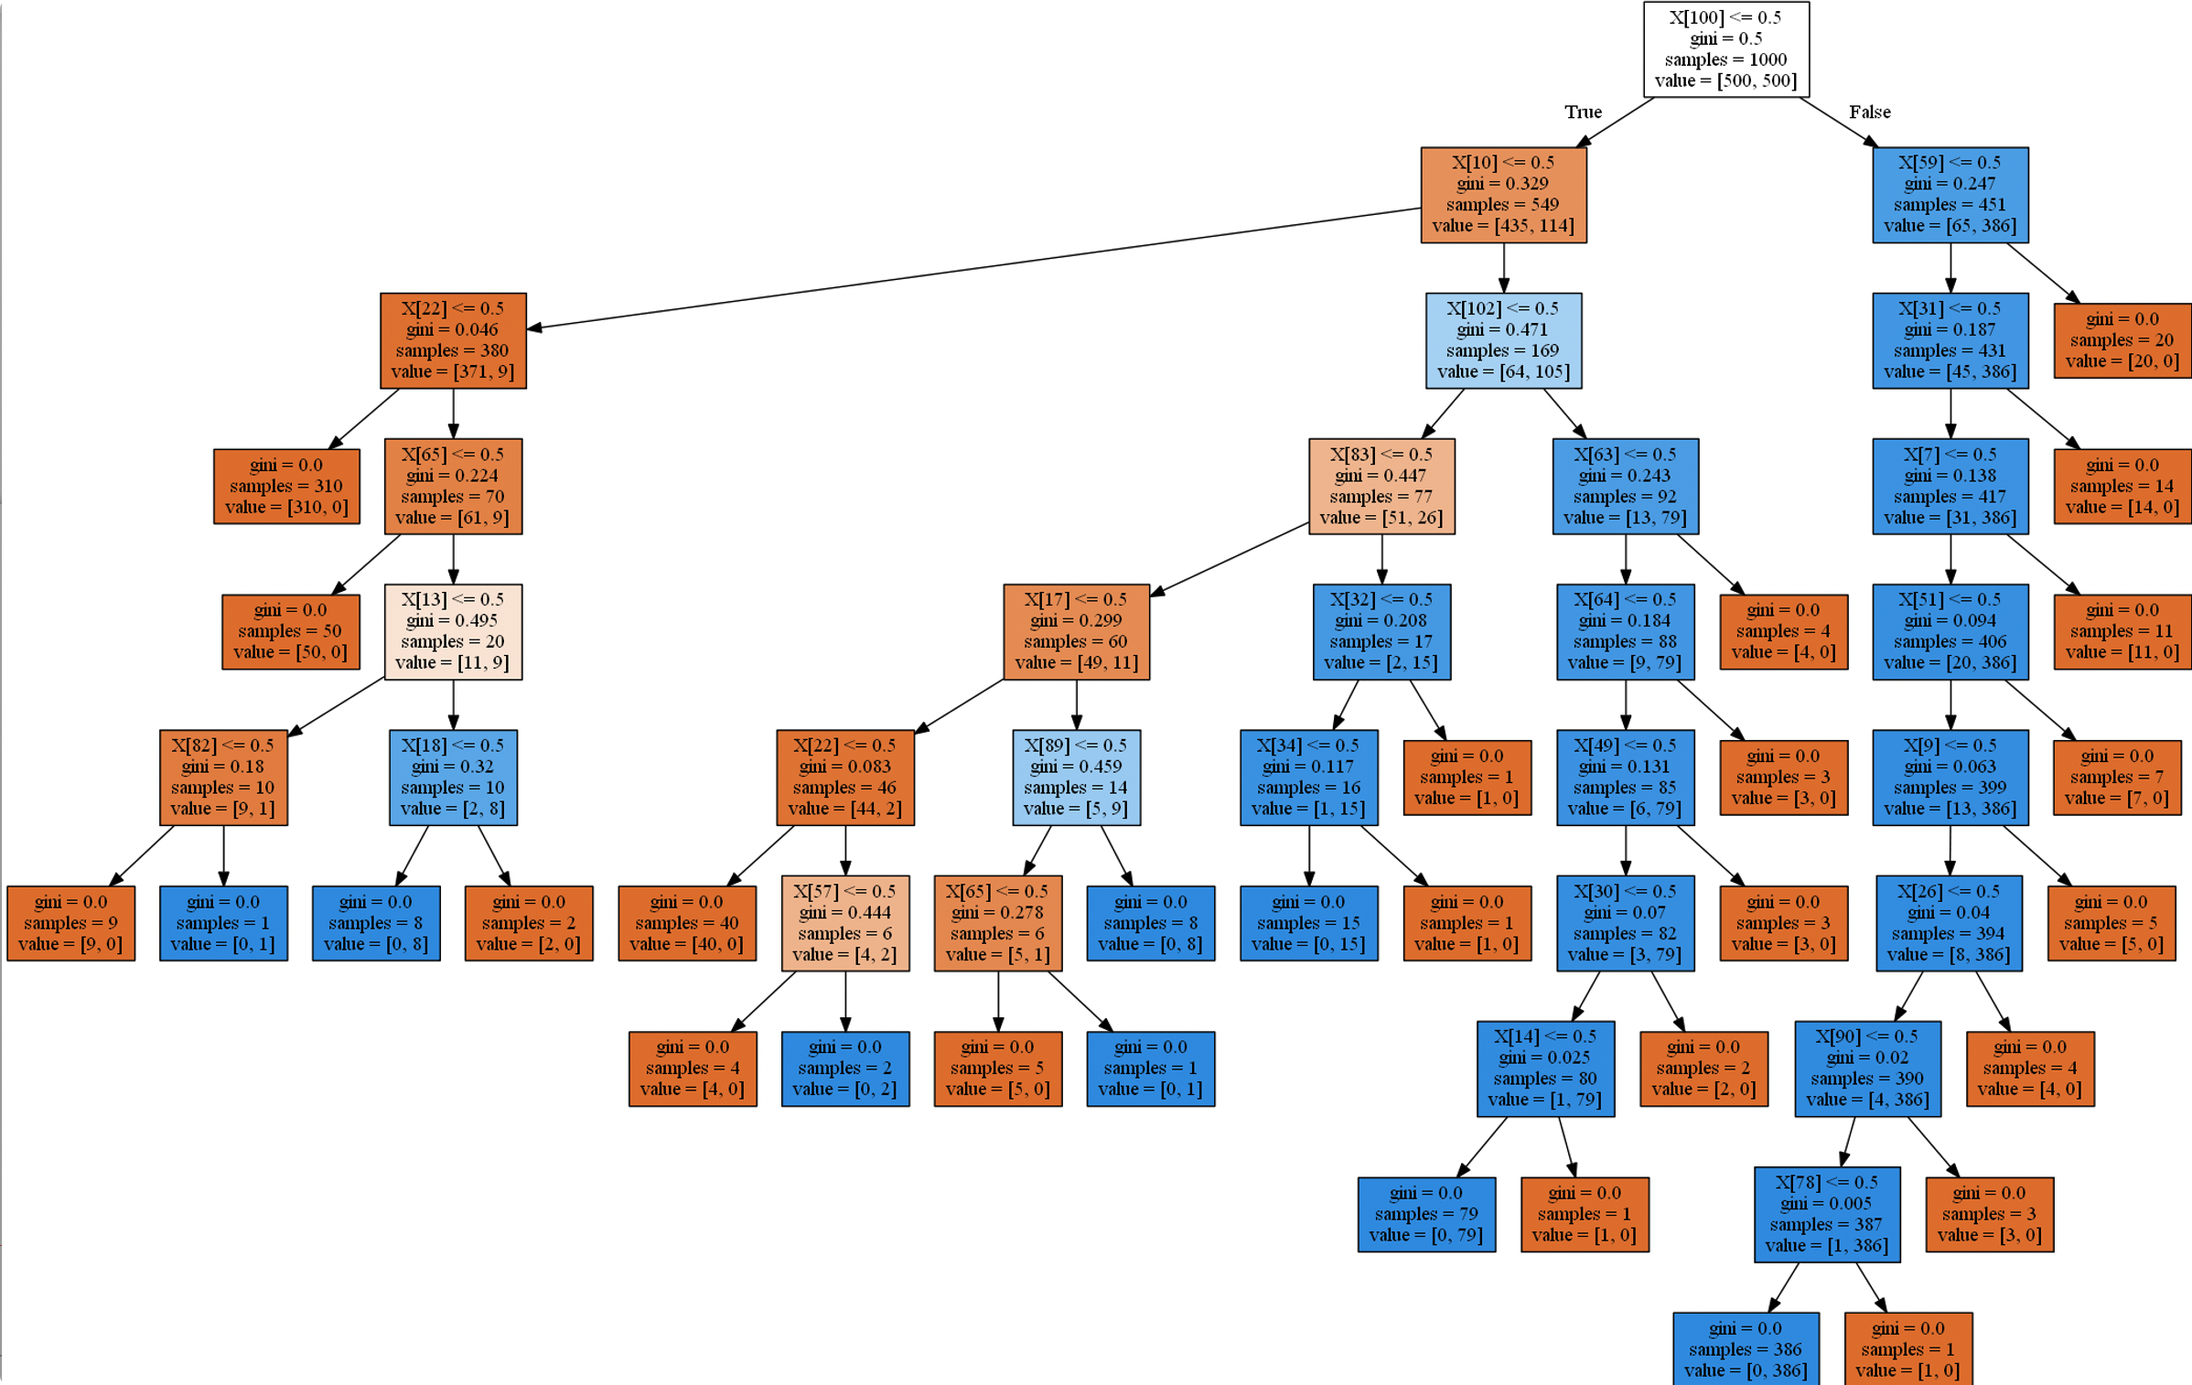

Didn’t change

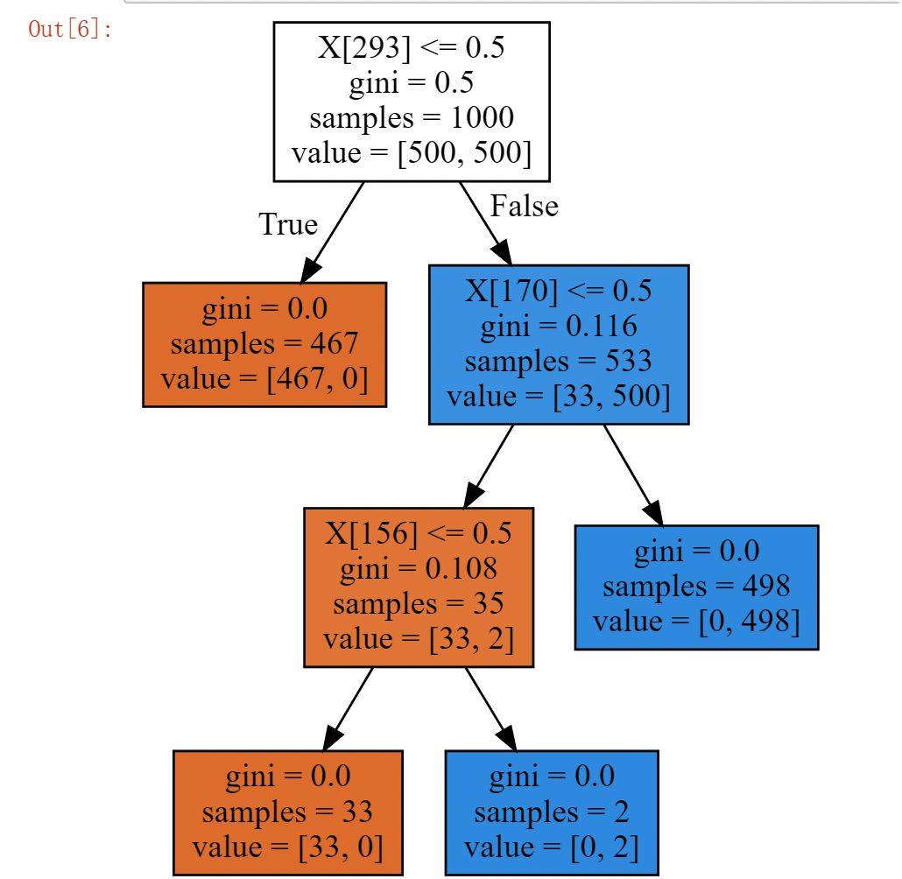

With one row:

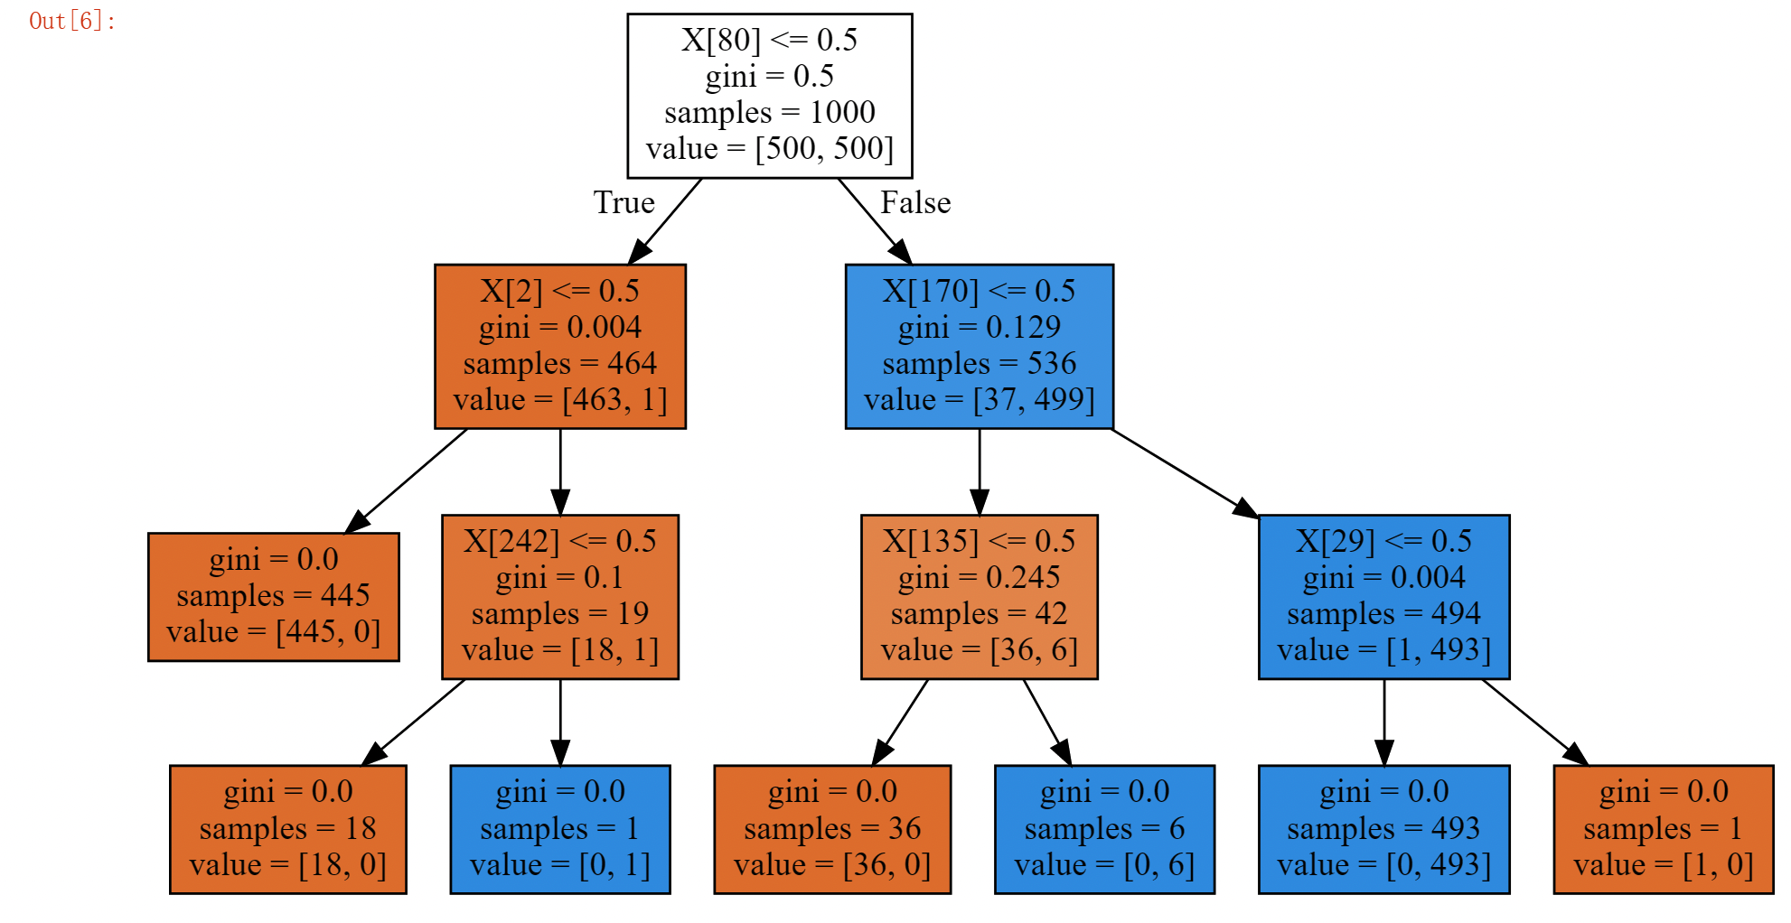

With 2 rows:

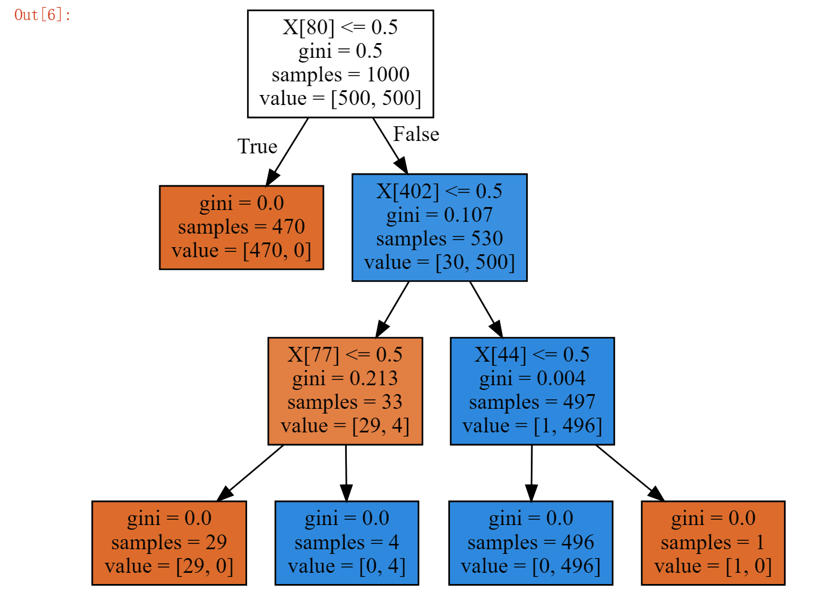

With3 rows:

